BANK LOAN REPORT | SUMMARY
KPI:
Total Loan Applications
SELECT COUNT(id) AS Total_Loan_Applications
FROM financial_loan;
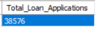
MTD Loan Applications
SELECT COUNT(id) AS MTD_Total_Loan_Applications
FROM financial_loan
WHERE MONTH(loan_date) = 12 AND YEAR(loan_date)=2021;
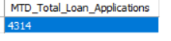
PMTD Loan Applications
SELECT COUNT(id) AS PMTD_Total_Loan_Applications
FROM financial_loan
WHERE
MONTH(loan_date) = 11 AND YEAR(loan_date)=2021;
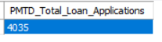
MTD Total Funded AMount
SELECT SUM(loan_amount) AS MTD_Total_Funded_Amount
FROM financial_loan
WHERE MONTH(loan_date) =12 AND YEAR(loan_date) = 2021;
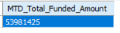
PMTD Total Funded Amount
SELECT SUM(loan_amount) AS PMTD_Total_Funded_Amount
FROM financial_loan
WHERE MONTH(loan_date) =11 AND YEAR(loan_date) = 2021;
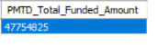
Total Amount Received
SELECT SUM(total_payment) AS Total_Amount_Received FROM financial_loan;
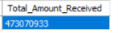
MTD Amount Received
SELECT SUM(total_payment) AS MTD_Total_Amount_Received
FROM financial_loan
WHERE MONTH(loan_date) = 12 AND YEAR(loan_date) = 2021;
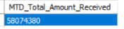
PMTD Total Amount Received
SELECT SUM(total_payment) AS PMTD_Total_Amount_Received FROM financial_loan
WHERE
MONTH(loan_date) = 11 AND YEAR(loan_date) = 2021;
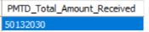
Average Interest Rate
SELECT ROUND(AVG(int_rate),2) * 100 AS Avg_intrest_rate
FROM financial_loan;
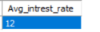
MTD Average Interest Rate
SELECT ROUND(AVG(int_rate),2) * 100 AS MTD_Avg_intrest_rate
FROM financial_loan
WHEREMONTH(loan_date) = 12 AND YEAR(loan_date) = 2021;
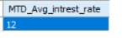
PMTD Average Interest Rate
SELECT ROUND(AVG(int_rate),2) * 100 AS PMTD_Avg_intrest_rate
FROM financial_loan
WHEREMONTH(loan_date) = 11 AND YEAR(loan_date) = 2021;
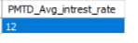
Average DTI (Debt to Income) Ratio
SELECT ROUND(AVG(dti),2) * 100 AS Avg_dti_percent
FROM financial_loan;
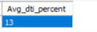
MTD Average DTI
SELECT ROUND(AVG(dti),2) * 100 AS MTD_Avg_dti_percent
FROM financial_loan
WHERE MONTH(loan_date) = 12 AND YEAR(loan_date) = 2021;
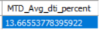
PMTD Average DTI
SELECT ROUND(AVG(dti),2) * 100 AS PMTD_Avg_dti_percent
FROM financial_loan WHERE
MONTH(loan_date) = 11 AND YEAR(loan_date) = 2021;

GOOD LOAN VS BAD LOAN ISSUED
Good Loan Percent
SELECT (
COUNT(
CASE WHEN loan_status = 'Fully Paid' OR loan_status = 'Current' THEN id END) * 100) /
COUNT(id) AS Good_loan_percentage
FROM financial_loan;
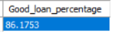
Total Good Loan Applications
SELECT COUNT(id) AS Total_Good_Loan_Application
FROM financial_loan
WHERE loan_status = 'Fully Paid' OR loan_status = 'Current';
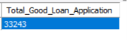
Good Loan Funded Amount
SELECT SUM(loan_amount) AS Good_Loan_Funded_Amnt
FROM financial_loan
WHERE loan_status = 'Fully Paid' OR loan_status = 'Current';
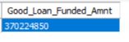
Good Loan Amount Received
SELECT SUM(total_payment) AS Good_Loan_Received_Amnt
FROM financial_loan
WHERE loan_status = 'Fully Paid' OR loan_status = 'Current';
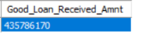
BAD LOAN ISSUED
Bad Loan Percentage
SELECT (
COUNT(CASE WHEN loan_status = 'Charged Off' THEN id END) * 100) /
COUNT(id) AS Bad_loan_percentage
FROM financial_loan;
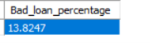
Total Bad Loan Application
SELECT COUNT(id) AS Bad_loan_application
FROM financial_loan
WHERE loan_status = 'Charged Off';
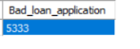
Bad Loan Funded Amount
SELECT SUM(loan_amount) AS Bad_loan_funded
FROM financial_loan
WHERE loan_status = 'Charged Off';
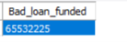
Total Bad loan Amount Received
SELECT SUM(Total_payment) AS Total_bad_amnt_recieved
FROM financial_loan
WHERE loan_status = 'Charged Off';
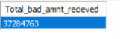

LOAN STATUS
Good Loan Issued
SELECT loan_status,
COUNT(id) AS Total_Loan_Application,
SUM(loan_amount) AS Total_Funded_Amount,
SUM(total_payment) AS Total_Amount_Recieved,
ROUND(AVG(int_rate * 100),2) AS Avg_interest_rent,
ROUND(AVG(dti * 100),2) AS Avg_DTI_percent
FROM financial_loan
GROUP BY loan_status
ORDER BY Total_Loan_Application DESC;
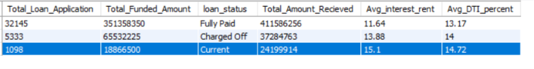
Good Loan Issued
SELECT loan_status,
SUM(loan_amount) AS MTD_Funded_Amount,
SUM(total_payment) AS MTD_Received_Amount
FROM financial_loan
WHERE
MONTH(loan_date) = 12 AND YEAR(loan_date) = 2021
GROUP BY loan_status;
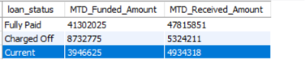
BANK LOAN REPORT | OVERVEIW
Months Status
SELECT
MONTH(loan_date) AS Month_num,
MONTHNAME(loan_date) AS Months,
COUNT(id) AS Total_Application,
SUM(loan_amount) AS Total_Funded_Amount,
SUM(total_payment) AS Total_Received_Amount
FROM financial_loan
GROUP BY MONTHNAME(loan_date), MONTH(loan_date)
ORDER BY Month_num;
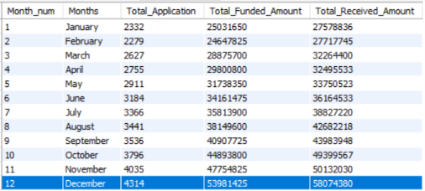
State Status
SELECT
address_state AS State,
COUNT(id) AS Total_Application,
SUM(loan_amount) AS Total_Funded_Amount,
SUM(total_payment) AS Total_Received_Amount
FROM financial_loan
GROUP BY address_state
ORDER BY Total_Application DESC;
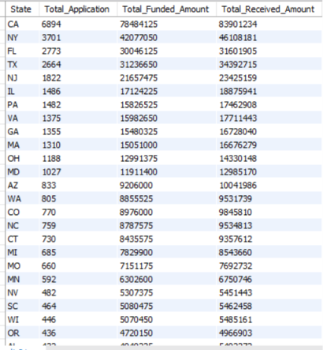
Employee Length Analysis
SELECT emp_length,
COUNT(id) AS Total_Application,
SUM(loan_amount) AS Total_Funded_Amount,
SUM(total_payment) AS Total_Received_Amount
FROM financial_loan
GROUP BY emp_length
ORDER BY Total_Application DESC;
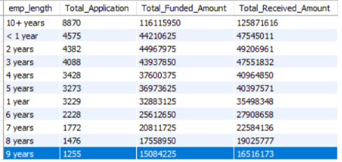
Good Loan Purpose Analysis
SELECT purpose,
COUNT(id) AS Total_Application,
SUM(loan_amount) AS Total_Funded_Amount,
SUM(total_payment) AS Total_Received_Amount
FROM financial_loan
GROUP BY purpose
ORDER BY Total_Funded_Amount DESC;
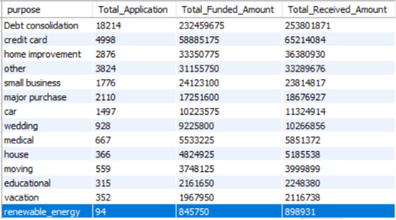
Home Owenership Analysis
SELECT home_ownership,
COUNT(id) AS Total_Application,
SUM(loan_amount) AS Total_Funded_Amount,
SUM(total_payment) AS Total_Received_Amount
FROM financial_loan
GROUP BY home_ownership;
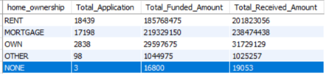
‘A’ Grade Application and Status
SELECT home_ownership,
grade,
COUNT(id) AS Total_Application,
SUM(loan_amount) AS Total_Funded_Amount,
SUM(total_payment) AS Total_Received_Amount
FROM financial_loan
WHERE grade = 'A'
GROUP BY home_ownership;
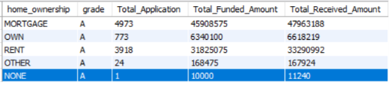
‘A’ Grade Application in California State
SELECT home_ownership,
grade,
address_state AS State,
COUNT(id) AS Total_Application,
SUM(loan_amount) AS Total_Funded_Amount,
SUM(total_payment) AS Total_Received_Amount
FROM financial_loan
WHERE grade = 'A' AND address_state = 'CA'
GROUP BY home_ownership
ORDER BY Total_Application DESC;
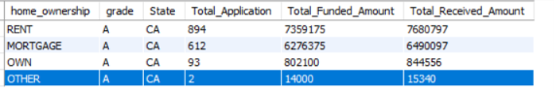

Power BI Dashboard

